Virendra Garhewal

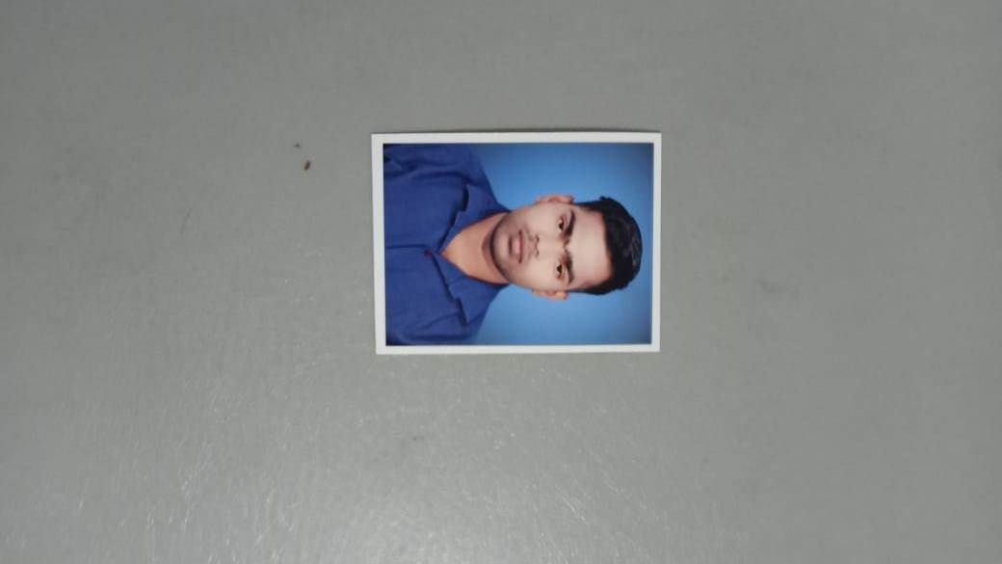

Phone No. +91 8817423869

Local address 27 kholi mangla chowk bilaspur

E-MAIL – aryangarhewal0107@gmail.com

Objective:-

To work hard and grow in a positive and healthier way professionally by gaining and utilizing knowledge to the zenith in the field of office management, which can help me to contribute my skill for the development of the institution.

Experience / Internship:-

* Working in NARAYANI HOSPITAL as an RMO. from July-2019 to Till now.
* Work as a Staff Nurse Unity Hospital from 2017 to 2019
* Work as a OT Tech. Mishra Nursing Home from 2015 to 2017

Education:-

* B.A.M.S. (2017):-

( I..A.M.I.)=Vallabha Nagar Raipur (PC.G..)

* DCA (2016):-

Diploma Of Computer Application in year 2018 from Pt. Sundar Lal Sharma Open University Bilaspur.

* Higher Secondary (2013):

Complete Senior School Certificate Examination (CGBSE) with 65% marks in year 2013 from Netaji Subhash Chandra Bose higher secondary School Ratanpur .

* High School (2011):

Complete high school Certificate Examination (CGBSE) with 58.33% marks in year 2011 from shri vinayak . high School bharari .

Computer Knowledge:-

Basic knowledge – MS WORD, MS EXCEL,

Personal Information:-

* Fathers name : Lt Mr. Basant garhewal
* Date of Birth : 10th of April 1994
* Nationality : Indian
* Religion : Hindu
* Language : Hindi English
* Permanent address : Vill- Parsada Post – Pausara, Block –Bilha Dist - Bilaspur (C.G.)

Declaration:

I hereby declare that the particulars mentioned above are true to the best of my knowledge and belief.

Date - 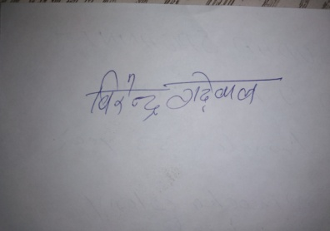

Virendra Garhewal